**National University of Computer and Emerging Sciences**



# Programming Fundamentals CS118 Laboratory Manual

Course Instructor Mirza Mubasher Baig

Lab Instructor#01 Fraz Yousaf

Lab Instructor#02 Samia Akhter

Semester FALL 2021

FAST School of Computing FAST-NU, Lahore, Pakistan

**National University of Computer and Emerging Sciences**

|  |  |  |  |  |
| --- | --- | --- | --- | --- |
| National University of Computer and Emerging Sciences - Wikipedia | **Lab No 6** | | | |
| **Course Name** | Programming Fundamentals | **Course Code** | CS188 |
| **Program** | BS(DS) | **Semester** | Fall 2021 |
| **Duration** | 2.5 hours | **Total Points** |  |
| **Lab Date** | 05-Nov-2021 | **Weight** | 3% |
| **Section** | BDS-1A | **Page(s)** | 9 |

**Topics Covered: Functions**

Use Visual Studio Community 2019 or simple IDE available at <https://www.onlinegdb.com/>to write the programs

**Submission Instructions:**

#### Save all .cpp files according to the following naming convention

{ROLLNO}_{TASKNO}.cpp FOR EXAMPLE. 21L-XXXX _P01.cpp, 21LXXXX_P02.cpp, 21L-

XXXX_P03.cpp

1. Now create a new folder according to the following naming convention

{Section}_{ROLLNO}_{LABNO} e.g. C1_21L-XXXX_L06, C2_21L-XXXX_L06

1. Move all of your .cpp files to this newly created directory and compress it into a single

.zip file.

1. Submit this compressed file on Google Classroom.

**Functions in C++**

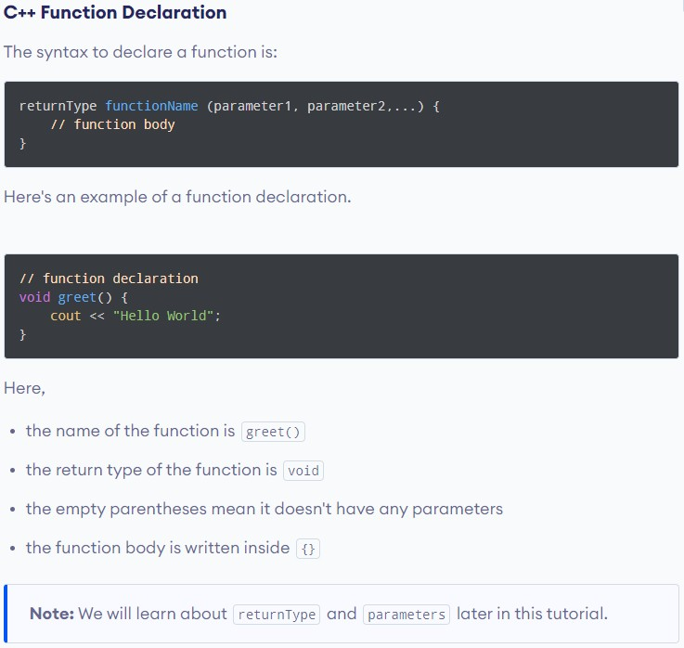

Calling a Function

In the above program, we have declared a function named greet() . To use the greet () function, we need to call it.

Here's how we can call the above greet( ) function.



#1nc I ude<1os t reams

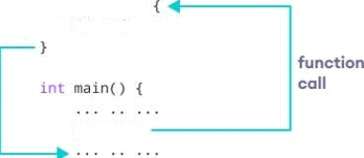

vold greet t )

/ / code

How Function works in C++

# (Don’t submit code for this problem)

**Practice Problem**

Write a function named ***power*** that takes two integer parameters ***a*** and ***b***. And returns the power as 𝒂𝒃**.**

**Input Format:**

* First line contains input **a**
* Second line contains input **b**

## Note:

* 𝑎𝑏 = 1, 𝑖𝑓 𝑏 = 0

Sample Input#1: 12

2

Sample Output#1: 144

Sample Input#2: 3

4

Sample Output#2: 81

Sample Input#3: 15

0

Sample Output#3: 1

Sample Input#4:

-5

3

Sample Output#4:

-125

# (Submit codes for questions starting from here)

**Problem#01**

Write a function named ***check palindrome*** that takes an integer parameter ***number and*** displays the corresponding output.

Palindrome: A palindrome is a word, number, phrase, or other sequence of characters which reads the same backward as forward, such as madam or racecar or the number 10201

**For example:**

11211 is palindrome

1222 is not a palindrome.

4444 is a palindrome.

**Problem#02**

Write a function named ***rectangle*** which takes two integers ***height*** and ***width*** as parameters of the function. That function is responsible to draw the rectangular pattern shown below in the Sample Cases.

**Note:**

* If user enters a non-positive number, display **“Rectangle printing is not possible.”**
* Use of Nested Loops is Mandatory

Sample Input#1: 3

4

Sample Output#1: OOOO

OOOO OOOO

Sample Input#2: 9

1

Sample Output#2: O

O O O O O O O O

Sample Input#3:

2

-7

Sample Output#3:

Rectangle printing is not possible.

Sample Input#4:

0

12

Sample Output#4:

Rectangle printing is not possible.

# Problem#03

# Write a function named *displayseries* that takes two integer parameter *number and rows and then* displays the corresponding series pattern.

For user input Starting Number = 5 and Rows = 6,

**output should be:**

5 * 6 * 7 * 8 * 9 * 0 *

1 * 2 * 3 * 4 * 5 *

6 * 7 * 8 * 9 *

0 * 1 * 2 *

3 * 4 *

5 *

**Note**: Code should be generic i.e. it should run for any starting number ranging from 0 to 9 and any row number.

# Problem#04

Write a program using the C++ programming language to print all the prime numbers between two given numbers by creating a function.

**Problem #5**

Write a program that inputs a sequence of non-negative numbers terminated by a negative value and show the sum, average, maximum and minimum of the non-negative numbers

|  |  |
| --- | --- |
| **Sample Input** | **Sample Output** |
| 10 20 30 40 50 -10 | Sum = 150  Average = 30  Maximum = 50  Minimum = 10 |
| 13 2 15 5 30 -10 | Sum = 65  Average = 13  Maximum = 30  Minimum = 2 |

# .